IN THE HIGH COURT OF JUDICATURE AT MADRAS
(Appellate Jurisdiction)
W.A. No. 1109 & 1110 of 2020
A. Adarsh,
No. 10-F, Stella Mary Nagar, 1st Street,
Thanjavur. ….Appellant
Vs.
National Testing Agency (Government Agency),
Rep. by its Governing Body,
Noida, Uttar Pradesh,
And 3 others. …Respondents
MEMO FILED ON BEHALF OF THE APPEALLANT
The above appeals have been listed for admission today (10/12/2020), however it was not listed today since the registration for Mop-up Counseling starts today, the same has to be urgently heard today. The case has to be listed before the Hon'ble 2nd Bench as per the Roster today. The contact number of the Counsel for Appellant is 9840227470/044-24350931, the E-Mail Address is “ kselvaraj.lawyer@gmail.com “.
Therefore, it is humbly prayed that this Hon'ble Court may be pleased to permit the Appellant to Mention to List the above Writ Appeals for hearing today (10/12/2020),
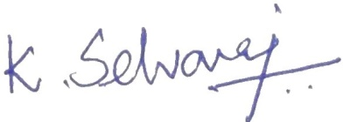
Dated on this the 10th day of December, 2020

Counsel for Appellant

